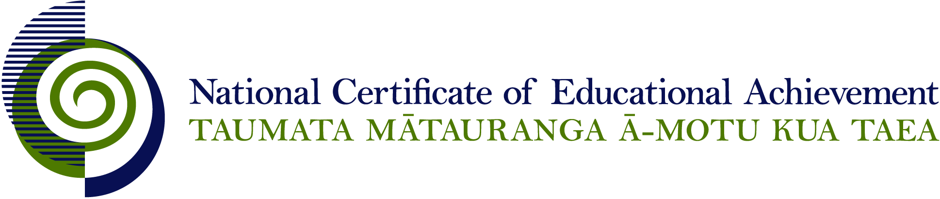

EXPIRED

NCEA Level 1 Music

Conditions of Assessment

General Information

Subject Reference | Music
Domain | Making Music
Level | 1

This document provides guidelines for assessment against internally assessed standards. Guidance is provided on:
- appropriate ways of, and conditions for, gathering evidence
- ensuring that evidence is authentic
- any other relevant advice specific to an achievement standard.

NB: It is expected that teachers are familiar with additional generic guidance on assessment practice in schools published on the NZQA website. This should be read in conjunction with these Conditions of Assessment.

For All Standards

Internal assessment provides considerable flexibility in the collection of evidence. Evidence can be collected in different ways to suit a range of teaching and learning styles and a range of contexts of teaching and learning. Care needs to be taken to allow students opportunities to present their best evidence against the standard(s) that are free from unnecessary constraints.

It is recommended that the design of assessment reflects and reinforces the ways students have been learning. Collection of evidence for the internally assessed standards could include, but is not restricted to, an extended task, an investigation, digital evidence (such as recorded interviews, blogs, photographs or film) or a portfolio of evidence.

It is also recommended that the collection of evidence for internally assessed standards should not use the same method that is used for any external standards in a programme/course, particularly if that method is using a time bound written examination. This could unfairly disadvantage students who do not perform well under these conditions.

A separate assessment event is not needed for each standard. Often assessment can be integrated into one activity that collects evidence towards two or three different standards from a programme of learning. Evidence can also be collected over time from a range of linked activities (for example, in a portfolio).This approach can also ease the assessment workload for both students and teachers.

Effective assessment should suit the nature of the learning being assessed, provide opportunities to meet the diverse needs of all students and be valid and fair.

Where manageable, and after further learning has taken place, students may be offered a maximum of one further opportunity for assessment against an assessment standard within a year.

Authenticity of student evidence needs to be assured regardless of the method of collecting evidence. This needs to be in line with school policy. For example, for an investigation carried out over several sessions, this could include teacher observations or the use of milestones such as meetings with students, journal or photographic entries recording progress etc.

Specific Information for Individual Internal Achievement Standards

Achievement Standard Number | 91090 Music 1.1
Title | Perform two pieces of music as a featured soloist
Number of Credits | 6
Version | 3

Ideally, the audience should include the assessor. The audience could comprise class members, other school students, and/or members of the community.

A second assessment opportunity should be offered to any student who does not meet the standard on the first attempt.

Achievement Standard Number | 91091 Music 1.2
Title | Demonstrate ensemble skills through performing a piece of music as a member of a group
Number of Credits | 4
Version | 3

Ideally, the audience should include the assessor, and could comprise class members, other school students, or members of the community.

A second assessment opportunity should be offered to any student who does not meet the standard on the first attempt.

Achievement Standard Number | 91092 Music 1.3
Title | Compose two original pieces of music
Number of Credits | 6
Version | 3

Each completed individual composition must be accompanied by a statement of authenticity testifying that the composition is the student’s own work. The teacher should authenticate work in progress as the student develops musical ideas.

The student’s individual creative contribution to collaborative composition will be assessed by teacher observation of the composition process and performance. Teacher/student conferencing, student annotations and diaries, and/or snapshot videos of collaborative processes are all ways of verifying student contribution. Videoed/audio/written/digital evidence can all be used to identify and verify the individual student’s creative contribution to the collaborative process.

A second assessment opportunity should be offered to any student who does not meet the standard on the first attempt.

Achievement Standard Number | 91095 Music 1.6
Title | Demonstrate knowledge of two music works from contrasting contexts
Number of Credits | 6
Version | 3

Where appropriate, evidence must be accompanied by a statement of authenticity testifying that it is the student’s own work. The teacher should authenticate work in progress.

A second assessment opportunity should be offered to any student who does not meet the standard for a particular assessment of the works.

